Version History
Ver. No. | Authors | Date | Reviewers | Review Date | Release Date
1.0 | Managed IT Service Team | 27-Aug-2018 | QMF | 31-Aug-2018 | 03-Sep-2018
1.1 | Managed IT Service Team | 4-Dec-2018 | QMF | 7-Dec-2018 | 11-Dec-2018

Change History
Ver. No. | Section | Date | Change Information | RFC No.
1.0 | All | 03-Sep-2018 | New Release | -
1.1 | 4.0 | 11-Dec-2018 | Modified list of Forms and checklist | Document Modification Request Form

Table of Contents
1.0 Objectives 4
2.0 Scope 4
3.0 Policy 4
3.1 Policy Statement 4
3.2 Framework to Support or Implement this Policy 4
4.0 References to (checklists, forms, guidelines, lists, standards, templates, other processes) 4
5.0 Entry Criteria 5
6.0 Responsibilities 5
7.0 Process Description 6
7.1 Project Management 6
7.2 Service Design Management 6
7.2.1 Coordinate Service Design 6
7.2.2 Prepare Service Management Plan and other documents 6
7.2.3 Service Level Management 6
7.2.4 Risk Management 7
7.2.5 Capacity Management 7
7.2.6 Availability Management 7
7.2.7 IT Service Continuity Management 7
7.2.8 Compliance Management 7
7.2.9 Supplier Management 7
7.2.10 Monitoring of Service Activities 7
7.3 Service Level Management 7
7.3.1 Identify Service Level Requirements 7
7.3.2 Define and Baseline Agreements 8
7.3.3 Maintain the Service Level Management Framework 8
7.3.4 Monitor, Report and Ensure Service Quality 8
7.4 IT Services Continuity Management 8
7.4.1 Plan for IT Service Continuity Management 8
7.4.2 Design Services for Continuity 9
7.4.3 Training, Review and Testing 9
7.5 Information Security Management 9
7.5.1 Design of Security Controls 9
7.5.2 Implement Security Controls 10
7.5.3 Management of Security incidents and Evaluation 10
7.6 Service Transition Management 10
7.6.1 Change Management and Change Evaluation 10
7.6.2 Transition Planning and Support 10
7.6.3 Application Development (If required) 10
7.6.4 Release and Deployment Management 11
7.6.5 Service Validation and Testing 11
7.6.6 Service Asset and Configuration Management 11
7.6.7 Knowledge Management 11
7.7 Service Change Management 11
7.7.1 Record / Raise Change Request 11
7.7.2 Scrutinize Change Request 11
7.7.3 Analyze Change Impact 11
7.7.4 Accept / Reject Change Request 11
7.7.5 Implement approved changes to the Configurable Items 12
7.7.6 Deploy on Test Environment 12
7.7.7 User Group Tests and Confirm Changes 12
7.7.8 Update Status of Change Request 12
7.8 Service Release Management 12
7.8.1 Prepare release strategy plan/policy and review 12
7.8.2 Prepare release / build 12
7.8.3 Prepare release/build package for production environment 13
7.8.4 Deploy the release/build into production environment 13
7.8.5 Provide Early Life Support (ELS) / Infant care support 13
7.8.6 Release closure 13
7.9 Incident Management 13
7.9.1 Log Call 13
7.9.2 Verify Call with SLA 13
7.9.3 Assign Call 14
7.9.4 Analyze and Resolve Call 14
7.9.5 Escalate Call 14
7.9.6 Close Call 14
7.9.7 Periodic Review and Reporting of Support Services 14
7.10 Problem Management 15
7.10.1 Problem Identification & Notification 15
7.10.2 Problem Determination (Logging, Categorization and Prioritization) 15
7.10.3 Problem Diagnosis and Resolution 15
7.10.4 Problem Tracking & Control 16
7.10.5 Problem Closure 16
7.10.6 Problem Review 16
7.10.7 Problem Management Reporting 16
7.11 Continual Service Improvement 16
8.0 Quality Mechanisms 16
Quality Objectives 17
9.0 Identified Risks 17
10.0 Exit Criteria 17

Managed IT Services Process

Objectives
The objective of this document is to define processes for Managed IT Services Team for better performance.

Scope
This process applies to all processes, and or any sub-process related to the Managed IT Services.

Policy

Policy Statement
- NA

Framework to Support or Implement this Policy
- NA

References to (checklists, forms, guidelines, lists, standards, templates, other processes)
Checklists | Service Catalogue | QMS-L4-CK-MKT-04
Forms | Risk Management Plan | QMS-L4-FR-MR-03
Forms | Service Management Plan | QMS-L4-FR-MTS-01
Forms | Knowledge Base Document Template | QMS-L4-FR-PM-08
Forms | Issue Tracking Sheet | QMS-L4-FR-MTS-02
Forms | Problem & Known error database log | QMS-L4-FR-MTS-03
Forms | Site Document | QMS-L4-FR-MTS-04
Forms | System Study Document | QMS-L4-FR-MTS-05
Forms | Schema assessment /Security Policy document | QMS-L4-FR-MTS-06
Forms | Backup Policy Document | QMS-L4-FR-MTS-07
Forms | Monthly Service Report | QMS-L4-FR-MTS-08
Forms | Incident Report (Intrusion and Breaches) | QMS-L4-FR-MTS-09
Forms | Test Reports | QMS-L4-FR-MTS-10
Forms | Release Note | QMS-L4-FR-PM-15
Forms | Sign-off for all deliverables | QMS-L4-FR-MTS-11
Forms | Project Status Report (Support / Managed) | QMS-L4-FR-PM-10
Guidelines | NA | NA
Lists | NA | NA
Standards | NA | NA
Other Processes | NA | NA

Entry Criteria

Inputs | Source Processes
Service Level Requirements (SLA, OLA, UC) | Managed IT Service Process Section 7.2
Capacity utilization reports | Managed IT Service Process Section 7.1.5
Availability Reports | Managed IT Service Process Section 7.1.6
Workaround / Solutions | Managed IT Service Process Section 7.9
New Service / Changed Service | Managed IT Service Process Section 7.2.1
IT Service Continuity Updates to SLA and OLA | Managed IT Service Process Section 7.1.6
Security Updates to SLA and OLA | Managed IT Service Process Section 7.4
Data on Availability of Services | Managed IT Service Process Section 7.1.6
Risk Analysis | Managed IT Service Process Section 7.1.4
SLA | Managed IT Service Process Section 7.2.2
Security Requirements | Managed IT Service Process Section 7.4
Service Management Plan | Managed IT Service Process Section 7.1
SLA, OLA , Underpinning Contracts | Managed IT Service Process Section 7.2.2
Schema assessment /Security Policy document | Managed IT Service Process Section 7.4
Configurable Items (CIs) | Managed IT Service Process Section 7.5.6
Issue / query received from the client | Managed IT Service Process Section 7.2.4
Known Error Database | Managed IT Service Process Section 7.8.4
Incident data | Managed IT Service Process Section 7.4.3

Responsibilities

Role | Responsibilities
Service Design Manager / PM | - Responsible for overall Process  - Responsible for the overall process
Delivery Head | - Approval of New Service / Changed Service
IT Service Continuity Manager / PM | - Responsible for overall process
Project /Service Manager | - Responsible for overall Process
Project Manager (PM) / Incident Manager (IM) | - Responsible for overall process
Support Coordinator (SC) / Primary consultant | - Responsible for day-to-day functioning of the Support Services
Analyst | - Analyze and provide appropriate resolution to the issue / query
Problem Manager (PBM) | - Responsible for overall process

Process Description

Overview Diagram
Please refer to respective processes for diagram.

Project Management
- Project Initiation and Project Closure activities would be implemented for all projects
- The project will implement other activities from Project Management Process, as applicable

Service Design Management
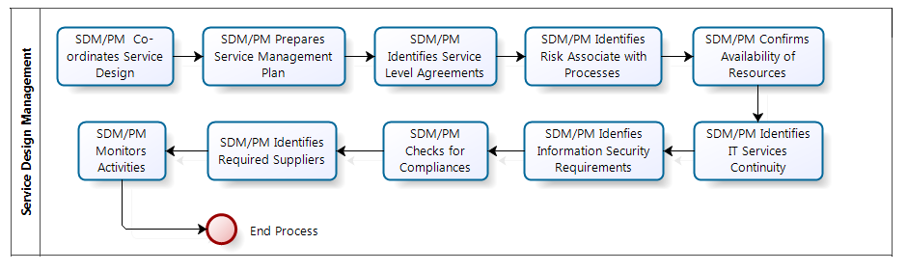

Coordinate Service Design
- Service Design Manager / PM understands and develops Service Design resources and capabilities,
- Service Design Manager / PM ensure that a consistent approach to designing new or changed services is adopted across all services / Projects.

Prepare Service Management Plan and other documents
- PM creates / updates the Service Management Plan using the Service Management Plan Template
- Delivery Manager reviews the Service management plan
- PM ensures that following documents are created / updated :
- Site Document: describes infrastructure of client and basic information of the services
- System Study Document: describes the present technical environment of the client in relation to our SOW
- Schema assessment :provides the schema information regarding the existing schemas on customer’s Database
- Security Policy document: recommends implements and reviews Security Policy specific to the area of support provided.
- Backup Policy Document: Recommends implements and documents Backup Policy as per client’s business requirement with contingency check.
- Service Design Manager / PM Plans design activities considering
- Which projects / Services or Changes are required to undergo the formal Service Design stage, and
- Who needs to be involved in Service Design to ensure that all relevant aspects are considered

Service Level Management
- Service Level Management is done as per the Service Level Management Process

Risk Management
- Risk Manager / PM identify risk and perform Business Impact Analysis and update the same in the Risk section of the Service management plan.

Capacity Management
- Service Manager:
  - Identifies the bandwidth provided / available for the internet services
  - Server capabilities which include
    - Disk space
    - Databases
    - Memory
    - Number of Users
  - Number of Resources employed for the providing the services

Availability Management
- Availability Management is done as per the Availability Management Process

IT Service Continuity Management
- I-T Service Continuity Management is done as per the IT Service Continuity Management Process

Compliance Management
- PM monitors all compliance requirements and the measures applied, to ensure their enforcement by reviewing
- Results of regular process and system compliance assessments.
- Identified deviations from compliance requirements, as well as measures to correct the situation.
- Identified deviations Organization Policies and Regulations

Supplier Management
- PM identifies and manages the suppliers / vendors as required to fulfill the design requirements of the Services provided

Monitoring of Service Activities
- Service Design Manager / PM monitors the design activities performed by various Service Design processes
- Service Design Manager / PM determines if the new or changed service can be provided economically and is viable
- Service Design Manager / PM determines’ if the clients' requirements can be fulfilled or must be renegotiated.

Service Level Management
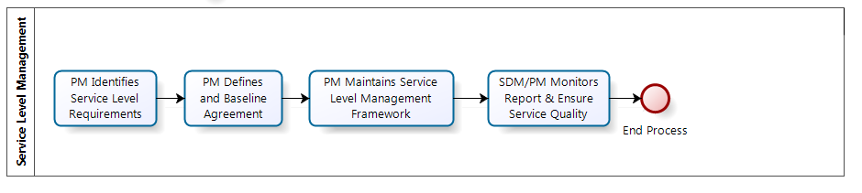

Identify Service Level Requirements
- Service Level Manager / PM
- Coordinates with the Customer to identify New Service / Changed service and requirements for the same
- Outlines the desired outcome of the service in terms of required service functionality and Services Levels
- Concurs with Customer with respect to the Service Catalog and Service Scope
- Service Level Manager / PM gives an update of the Service requirement, to design the service as per the Service Design Process

Define and Baseline Agreements
- Service Level Manager / PM in coordination with the internal service owners agree on the Operation Level agreement (OLA’s) specifying
- Services to be provided
- Responsibilities of both parties.
- Service Level Manager / PM negotiates and signs off on the underpinning contracts with the third party Vendors
- Service Level Manager / PM and Customer mutually agree and sign off on the Service level Agreement specifying the
- IT service
- Service level targets
- Service Acceptance Criteria and quality requirements, if any
- Responsibilities of the Service provider and the customer

Maintain the Service Level Management Framework
- Service Level Manager / PM maintain all Service Agreements which are necessary for delivering services to the customer

Monitor, Report and Ensure Service Quality
- Service level manager / PM
- Ensures that the required metrics / Data is collected.
- Analyzes the data metrics with respect to the expectations of the customer and agreed service level targets
- Creates the Service Report as per the agreed frequency and communicates it to the respective stakeholders.
- Service level manager / PM in coordination with/Service owner reviews Service Reports for:
- Breached Service Levels
- Service Levels approaching breach
- Downward trends in service levels
- Service level manager / PM identifies solutions for issues in services as per the Continual Service Improvement Process

IT Services Continuity Management

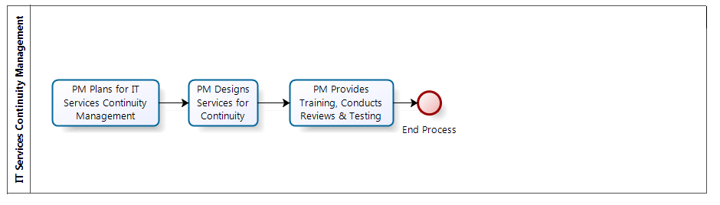

Plan for IT Service Continuity Management
- IT Service Continuity Manager / PM
- Establishes and communicates the policy, Scope and responsibilities on service continuity to all respective stakeholders
- Determines the command and control structure required to support a business interruption
- Considers issues like outstanding audit points, regulatory or client requirements and insurance organization stipulations, and compliance with standards
- Identifies the staffing, skills, facilities and services (including the IT services) necessary to enable critical and essential business processes to continue operating at a minimum acceptable level
- Identifies the time within which minimum levels of staffing, facilities and services should be recovered
- Identifies the time within which all required business processes / services and supporting staff, facilities should be fully recovered
- Identifies the relative business recovery priority for each of the IT services
- IT Service Continuity Manager / PM analyses the impact of failure on the availability of service.

Design Services for Continuity
- Determines risks that may give rise to service disruption or security violation and also identify appropriate risk responses or cost-justifiable counter measures
- Performs Business Impact Analysis due to loss of services considering but not limited to :
- Financial loss
- Public relations
- Morale
- Health and safety
- IT Service Continuity Manager / PM updates the IT Service Continuity section of the Service Management Plan considering the results of the Business Impact Analysis, Service Level Agreements (SLA), security requirements and external contracts and
- Identifies information needed to recover the IT systems in a disaster situation
- Identifies activities to manage the business during transition to normal operation once the service disruption has been resolved.
- Identifies recovery activities and procedures

Training, Review and Testing
- IT Service continuity manager / PM ensures that:
- All staff are aware of the service continuity requirements and its implications and are trained to implement their actions
- Plans are reviewed, verified and updated
- Plans are tested after every major business changes.
- Backup and recovery of IT service is monitored and tested

Information Security Management

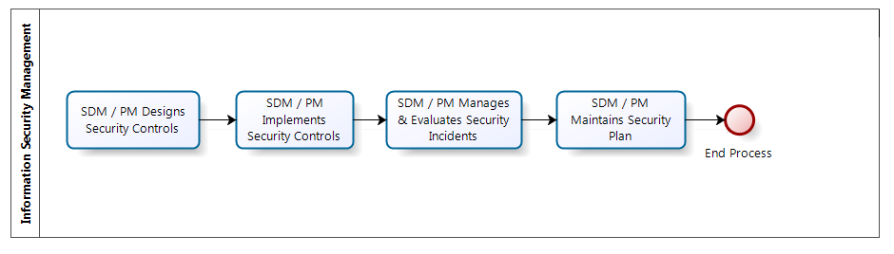

Design of Security Controls
- Information Security Manager / PM identifies security requirements as per the risk analysis performed
- Information Security Manager / PM studies Schema assessment / Security Policy document
- Information Security Manager / PM, as per the Service Level Management Process
- Negotiates with customer to define the Security requirements which needs to be part of the service level agreement (SLA)
- Coordinates with IT to define the Operational level agreements (OLAs), with respect to security requirements
- Specifies the security requirements with respect to the underpinning contracts

Implement Security Controls
- Information Security Manager / PM
- Classifies and manages IT assets in coordination with IT department
- Implements well defined job descriptions for all staff outlining security specific roles and responsibilities.
- Implements role based access control to ensure that only authorized personnel have access to information in the network
- Ensures that the controls are regularly tested and validated
- Shares regular status reports with customer

Management of Security incidents and Evaluation
- Information Security Manager / PM
- Ensures systems are in place to detect incidents and to minimize the damage incurred by security breaches.
- Evaluates compliance with respect to the security requirements and SLAs.
- Ensures that regular external and/or internal security audits are conducted to assess the adherence and identify any changes / improvement.
- In-case of any changes raises a change request using the Request for Change Form, , as per the Service change management process
- Creates reports for security-related incident if any, and shares with stakeholders

Service Transition Management

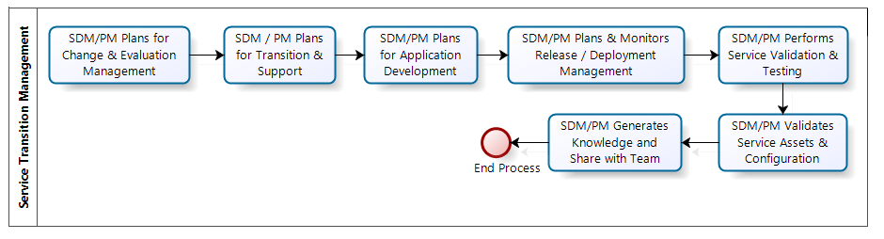

Change Management and Change Evaluation
- Change Manager / PM evaluates and manages changes to services as per the Change Management Process

Transition Planning and Support
- PM plans and coordinates the resources to deploy a major Release as per the Service Management Plan

Application Development (If required)
- PM ensures that any development of custom applications is done as per the Software Development Methodology
- PM identifies any customization required for vendor supplied products and communicates to the vendor appropriately

Release and Deployment Management
- Project Manager manages release and deployment of correct components as per the Release Management Process

Service Validation and Testing
- Project Manager ensures that deployed releases and the resulting services is tested as per the Testing Methodology Process, and these services conform to customer expectations

Service Asset and Configuration Management
- Project Manager ensures that information about configuration items required to deliver an IT service , including their relationships is maintained as per the Configuration Management Process and updated in the configuration section of the Service Management Plan

Knowledge Management
- PM updates the information-base related to best practices, Lessons Learnt and details of Reusable component using Knowledge Base Document Template,
- PM shares the same at the departmental and Organizational level Knowledge repository

Service Change Management

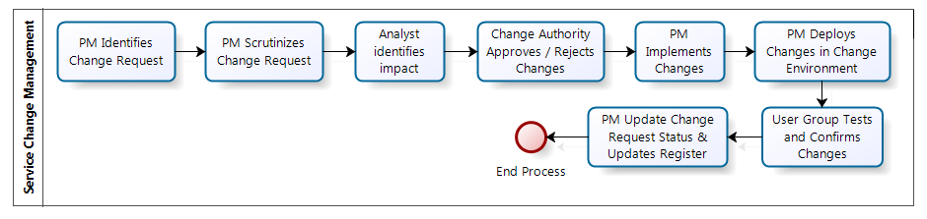

Record / Raise Change Request
- Support Coordinator (SC) logs the change request in the issue tracking sheet or identified tool
- PM / SM ensures that all the change requests are recorded using the Request for Change Form

Scrutinize Change Request
- PM / SM :
- Allocates a running serial number (change request No) to every RFC
- Scrutinizes the change request to determine whether to accept, reject or defer the request
- Ensures that the request contains all relevant information and returns the incomplete / improper RFC to the originator of change along with proper remarks
- Accepts the completed RFC form and forwards it to the Change Analyst for initial impact analysis
- Assigns a status to the change request in the Status section of RFC

Analyze Change Impact
- Change Analyst assesses the changes to be made and lists out the affected Configurable Items along with its detailed impact in terms of scope, schedule, effort and cost if any, associated with the changes in the Impact Analysis section of RFC
- PM / SM ensures that impact analysis is reviewed as per the Review Process

Accept / Reject Change Request
- PM / SM sends the change for Change Authority Boards (CAB) approval
- CAB accepts / rejects the proposed changes
- PM / SM updates the Status section of RFC accordingly

Implement approved changes to the Configurable Items
- PM / SM updates the schedule and assigns the tasks of preparing the change list to the team member/s and allocates appropriate person/s to implement the change
- The allocated resource obtains the CIs as per the Service Configuration Management Process PR28009, and incorporates the changes
- PM / SM verifies that changes are incorporated in the CI, tracks them as per the change list and ensures that the CI is checked-in as per the Service Configuration Management Process
- PM / SM ensures that change history of the affected CI is updated in the respective documents or using the -Change History Form, wherever necessary

Deploy on Test Environment
- PM / SM ensures that the changes are validated in the test environment as per the Testing Methodology and adequate System and Integration testing and UAT is performed

User Group Tests and Confirm Changes
- User Group Test the changes and accepts details
- PM / SM takes signoff off on the test environment and maintains the Test case report.
- PM / SM deploys the changes in the production environment as per the Service Release Management Process

Update Status of Change Request
- PM / SM:
- Updates the Status section of RFC
- Maintains information of all the change requests using the Change Request Register, which is also used for reporting status of change request periodically

Service Release Management

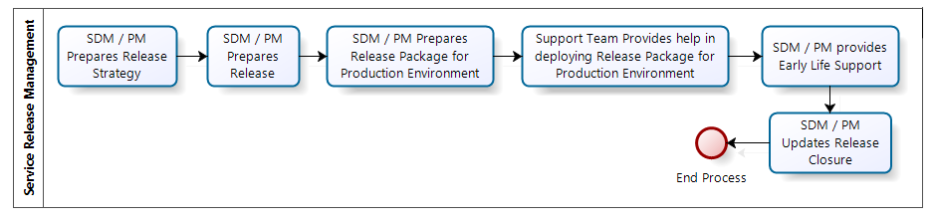

Prepare release strategy plan/policy and review
- PM / SM identifies the release strategy considering the following:
- Scope of the release considering New / Changed service to be released
- Test results with respect to UAT
- Release implementation schedule
- PM / SM ensures that the release strategy is reviewed and approved by the Customer PM

Prepare release / build
- PM / SM performs the following activities for release:
- Prepares the release note using the Release Note Form
- Shares the rollback plan with the deployment team
- Identifies the required configurable items for the release/build as per the Service Configuration Management process
- Ensures that the baseline audits are conducted
- Prepares the user manual or user instruction if required
- Ensures fulfillment of requirement for any other supportive documents as per the SOW

Prepare release/build package for production environment
- PM/SM in coordination with Customer PM ensures required environment exists at the production site for installation.
- PM/SM ensures that the impacted end users and stakeholders are informed about the release schedule
- PM/SM confirms if there are any minor changes with respect to production environment in terms of server IP address, file path changes etc.
- PM/SM gets approval of customer PM for deployment of release in production environment
- PM/SM in coordination with customer PM ensures that the end users are trained if required with respect to new release/build or change service

Deploy the release/build into production environment
- PM/SM in coordination with support team deploys the approved release/build in to the production environment as per the Release note
- PM/SM ensures that the customer PM verifies and validates the release in the production environment
- PM/SM in coordination with the customer PM confirms if the release is successful or not. Incase release is not successful, executes the rollback plan and communicates the same to all stake holders
- PM/SM obtains customer sign-off using the Sign-off Form, and feedback on successful release

Provide Early Life Support (ELS) / Infant care support
- PM/SM ensures that the support team resolves any post implementation operational issues faced by the end user

Release closure
- PM/SM identifies the number of successful/ Unsuccessful releases and performs analysis of the same.
- PM/SM in coordination with the support team ensures that adequate documentation & knowledge base is maintained with respect to release
- PM/SM in coordination with support team ensures that CR/Incident ticket with respect to the change are closed after approval from customer PM

Incident Management

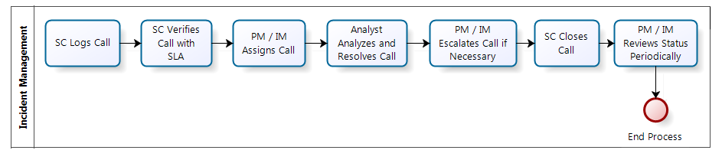

Log Call
- The SC receives the issue from the user
- The SC confirms if the issue is
- Planned event : Scheduled event
- Unplanned event : any disruption to service provided
- The SC logs the issue in the Issue Tracking Sheet, or the identified tool , allocates ID and updates the status of the issue as “Open”

Verify Call with SLA
- The SC verifies the call with respect to SLA. In case the call is beyond the scope of SLA, SC:
- Escalates it to the PM / IM for necessary action and updates the status as “Hold”
- On receipt of necessary direction updates the status to “Open” or “Closed” depending on the action to be taken
- The SC allocates the Call Type and Priority in coordination with the customer, computes the “Due date” based on the resolution time stated in the SLA and communicates the resolution time to the customer

Assign Call
- The SC in consultation with PM / IM assigns the issue to the identified Analyst and updates the status of call as “Assigned”

Analyze and Resolve Call
- The Analyst studies the issue and analyzes the possible causes of the issue / query and updates the status as “In Progress”
- The Analyst provides necessary resolution as follows:
- Searches the existing database (Known Error Database) of issues and their resolutions to provide an appropriate solution
- In case of changes / customization
- Estimates the efforts (including all stakeholders activities) in consultation with PM / IM
- Obtains customer approval
- Incorporates changes as per the Service Change Management Process
- Releases the changes as per the Service Release Management Process
- Provides Resolution to any other Issues
- The SC updates the status of the call as “Resolved”

Escalate Call
- SC Escalates call :
- To the customer in case the call is “Resolved” and the fix is to be applied by the customer
- To the customer in case providing resolution is beyond our control due to lack of information / knowledge
- To the Principle in case of the bug is detected in the system and also communicates the same to the customer and puts the status of the issue as “Hold”

Close Call
- The SC obtains an informal feedback on the resolution, and updates the status accordingly as follows;
- “Closed” - On receipt of acknowledgement of solution being accepted
- “Re-open” - On non-acceptance of the resolution action
- PM / IM studies the Issue Tracking Sheet or identified tool for recurring issues, if any, and allocates an Analyst to incorporate necessary corrective / preventive actions as per the Problem Management process

Periodic Review and Reporting of Support Services
- PM / IM conducts milestone reviews at predefined frequency as specified in the Service Plan
- PM / IM and SC periodically reviews the Issue Tracking Sheet
- PM / IM perform Root Cause analysis (RCA) on Severity 2 and 3 tickets and identifies root cause as per the Corrective and Preventive Action Process
- The SC generates a report on the following:
- number of calls received
- types of calls received
- time taken to respond to each call
- time taken to close the calls
- average respond time per call
- most frequent issue list
- number of outstanding calls to expedite the solution to be provided to the client
- feedback on resolution, if any

Problem Management

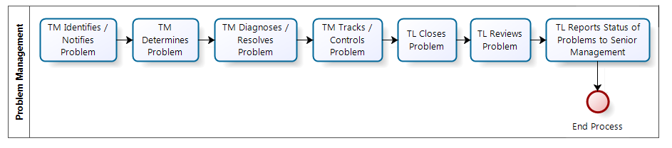

Problem Identification & Notification
- L1/ Helpdesk will raise the problem ticket in case there are more than one incidents with identical issues and identifies trends considering
- Number of incidents of a particular type
- Number of incidents within a particular site (increased/decreased)
- Number of incidents involving a particular CI or service(increased/decreased)
- Number of unresolved incidents(increased/decreased)
- Observed patterns that indicate hidden problems
- L1/ Helpdesk perform problem detection (reactive) based on incident notification from incident management process.

Problem Determination (Logging, Categorization and Prioritization)
- L1/L2/Helpdesk logs the problem, collects & analyze details and
- Determines if a new Problem Record needs to be created, or an existing Problem Record can be updated
- Determines IT Services and CIs affected
- Gathers the data collected by Incident Management
- Analyzes symptoms
- Selects the appropriate Service Support team who will respond to the Problem and verifies that an appropriate team member(s) has been assigned
- Updates the Incident Record if necessary/appropriate
- L2 classifies and prioritizes the problem using established criteria considering :
- Duration of Problem to date
- Impact (cost) to date
- Whether the system can be recovered, or whether it needs to be replaced
- Cost to fix
- Time to fix the Problem
- How extensive is the Problem

Problem Diagnosis and Resolution
- L1/L2 in coordination with the identified Service team perform diagnosis to identify if the problem can be associated with a Known Error in the Problem database else performs analysis as per the Corrective Action Process, to identify root cause, workarounds and potential solution to the problem
- L1/L2 in coordination with the identified Service team updates / Creates the problem as a Known Error in the Problem & Known error database log, along with the root cause, workarounds, and potential solutions to the problem and associate requisite records
- L1/L2 in coordination with the identified Service team plans the resolution and if necessary raises a Request for Change using the Request for Change Form, as per the Service Change Management Process

Problem Tracking & Control
- L1/L2 constantly monitors outstanding Problems & resolved Problems with regards to their current status; so that where it is needed necessary corrective measures may be introduced.

Problem Closure
- L1/L2 after successful implementation of problem solution updates the Problem database and related Known Error records are updated
- L2/L3 communicates the closure of the problem to respective stakeholders

Problem Review
- L2/L3 reviews the resolution of the problem to :
- Prevent recurrence
- Document any lessons learnt
- Verify whether the Problems marked as closed have actually been eliminated.
- Suggest any Process improvements

Problem Management Reporting
- L1/L2 creates Problem Management reports and ensures that appropriate stake holders are informed of
- Outstanding Problems,
- Current Processing-status
- Existing Workarounds and solutions

Continual Service Improvement

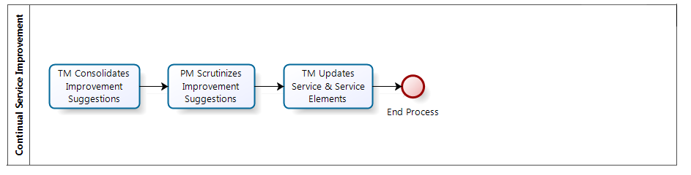

- Reviewing management information and trends to ensure that services are meeting agreed service levels „
- Reviewing management information and trends to ensure that the output of IT Service Management processes are achieving the desired results „
- Conducting internal audits verifying compliance „
- Conducting external and internal service reviews to identify CSI opportunities „
- Reviewing analyzed data „
- Presenting recommendations to senior management for improvement „
- Building effective relationships with the business and IT senior managers „

Quality Mechanisms

- Review of Service Management Plan
- Review of Service Reports
- Review of Plan and Audits
- Testing of Backup and Recovery activities
- Validation of Controls
- Testing of Build before releases
- Impact analysis and the authorization of the change
- Review of the changes implemented as per the change list
- Review of packaged deliverable
- Review of Issue Tracking Sheet
- Review of Problems

Quality Objectives

Sr. No | Objectives | Responsibility | Frequency of Measurement | Reporting of Measurement | Target to Achieve
1 | Achieve Internal/External SLA Parameter | Project Manager / Project Lead | Monthly | Issue Log / Ticketing System Dump | 85%
2 | Reduce Resource attrition | Project Manager / Project Lead | Quarterly | RHC | 5%
3 | CSAT | Project Manager | Half Yearly | CSAT Form | >=3

Identified Risks

- All risks identified for the process will be recorded into the Risk Management Plan (RMP)
- Risks will be reviewed and monitored as per the agreed schedule

Exit Criteria

Outputs
Service Management Plan Template
Knowledge Base Document Template
Amended SOW
Issue Tracking Sheet
Problem & Known error database log
Changed Service to be build / deployed
New Service to be build / deployed
Site Document
System Study Document
Schema Assessment /Security Policy document
Backup Policy Document
Risk Management Plan
Agreed SLA with Customer
Agreed OLA with Internal Team
Agreed underpinning contracts with Vendor
Monthly Service Report
Incident Report (Intrusion and Breaches)
Security Updates to SLA, OLA and Underpinning contracts
Test Reports
Released and Deployed Service
Changed Configurable Items
Release Note
Sign-off for all deliverables
Solution to the issue / query raised by the client
Root Cause Analysis
Workaround and solutions

